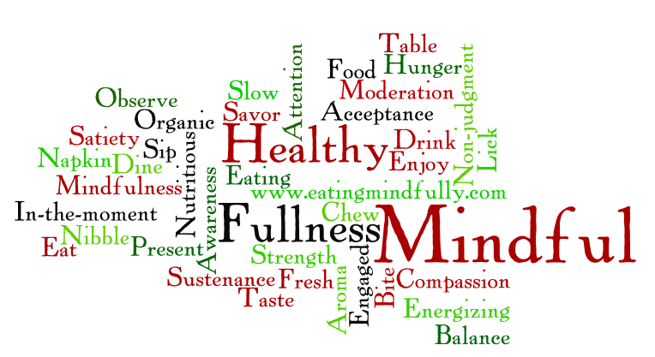

[www.eatingmindfully.com](http://www.eatingmindfully.com) @2012 Susan Albers